Specification- Screen оf Registration Form at [http://qa.noveogroup.com](https://mail.ngs.ru/Redirect/qa.noveogroup.com)  
Existing e-mail: 'user@domain.com', 'admin@domain.com', 'me@domain.com'.

**Test Cases:**

1. Press `Register` key without entering some data in the field `Name`.  
Expected result: It should show the message `Some data is incorrect. Please check it.`

Status: Done.

2. Check the validation for the field `Name` by entering one-character name.

Expected result: It shоuld show the message ` Name is too short. It have 2 characters or more.`

Status: Done.

3. Check different languages for the field `Name` by entering Cyrillic name.

Expected result: Accepted.

Status: After press `Register` key description for the field `Name` changed to entered Cyrillic. Detected in Google Chrome v.87, Opera v.73& v.74, Atom v.9

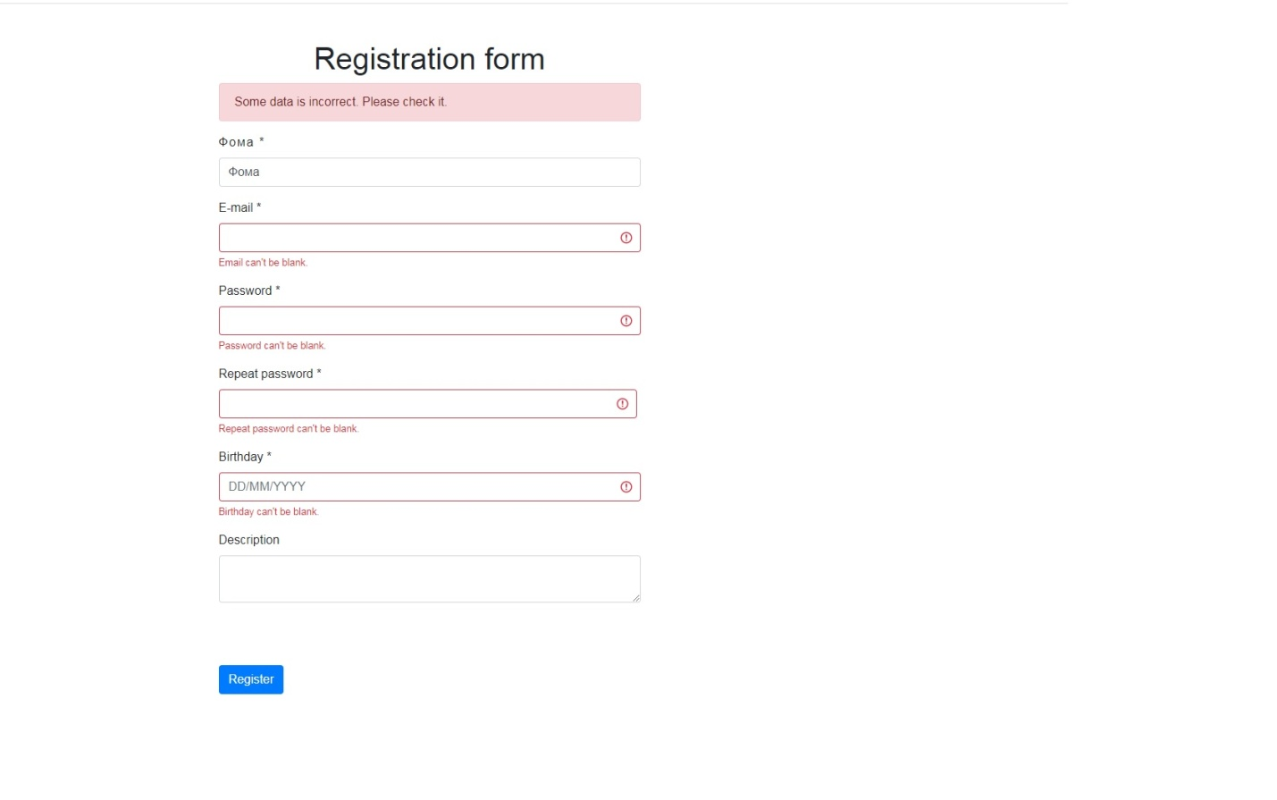

4. Check some combination with letters and symbols in the field `Name`.

Expected result: It should be done.

Status: Done.

5. Check the `E-mail` text field that has an e-mail address without @ symbol (aa.com).

Expected result: E-mail is not a valid e-mail address.

Status: Done.

6. Check the empty `E-mail` text field.

Expected result: E-mail can't be blank.

Status: Done.

7. Check the `E-mail` text field that has @ symbol written in words (aATa.com).

Expected result: E-mail is not a valid email address.

Status: Done.

8. Check the `E-mail` text field that has a missing dot in the e -mail address (a@acom).

Expected result: E-mail is not a valid e-mail address.

Status: Done.

9. Check the existing e-mail ('user@domain.com', 'admin@domain.com', 'me@domain.com')  
Expected result: A user with this e-mail address already exists.

Status: Another username with same e-mail address registered.

10. Press `Register` key without entering some data in the field `Password`.

Expected result: Password can't be blank.

Status: Done.

11. Check the password less than required (<8 of symbols)

Expected result: Password is too short. It have 8 characters or more.

Status: Done.

12. Check a few password combination with letters, space, symbols and numbers (>8 of symbols).

Expected result: It should be done.

Status: Done.

13. Enter alphanumeric value more than 32.

Expected result: Password is too long.

Status: Password accepted.

14. Press `Register` key without entering some data in the field `Repeat password`.

Expected result: Repeat password can't be blank.

Status: Done.

15. Check the copy-paste to repeat the password in the `Repeat password` field.

Expected result: Doesn`t work.

Status: Done.

16. Check the ` Birthday` field with the correct value (01/01/1900).

Expected result: It should be done.

Status: Done.

17. Check the ` Birthday` field with the incorrect value (010100, 01011900).

Expected result: Birthday is not a valid date.

Status: Done.

Some notes:

1. Text " Click Register to send form" appear only after left-button click between fields `Description` and `Register`(this is not a bug, this is a feature ©).

2. IE v11 doesn`t support this Registration Form.

3. Add some description for " * " (for example: these fields are mandatory to fill up).[modified in attached html-file]

4. Make the cursor`s shape change while it appear near to the "Register" button. It`s more usability. [modified in attached css-file]

5. Add some description for every field which have some character`s limit. [modified in attached html-file]

6. Make the limit of max length for password (it could help to avoid some problems with server`s processing of requests).

7. Make the simple-password checking script (using for example haveibeenpwned.com) to exclude the "easy-to-guess" passwords.

8.Should not be able to set password the same as username.

9. Different spelling of the name 'E-mail' as a field name, but 'Email' as description.